Assignment 4 - Individual PostgreSQL Database Project: School Schema
STUDENT NAME: 2332300138
ID: 2332300138
LINK GITHUB: https://github.com/thulubbs23-cpu/MIS443
Contents
1. Introduction to the School database
The School database is designed to manage essential information related to students, professors, courses, and enrollments. It demonstrates the use of relational database concepts, including primary keys, foreign keys, and table relationships. The database allows users to store, retrieve, and analyze academic information efficiently.
2. Description of the main tables and relationships
Students
The Students table stores information about each student, including their student ID, name, email address, enrollment date, graduation year, and major. The student_id is the primary key and uniquely identifies each student.
Professors
The Professors table stores information about professors, including their ID, name, email, department, and hire date. The professor_id is the primary key.
Courses
The Courses table stores information about the courses offered by the school, including course ID, course name, credits, department, and the professor responsible for teaching the course. The course_id is the primary key, while professor_id is a foreign key referencing the Professors table.
Enrollments
The Enrollments table records the courses that students register for. It contains the enrollment ID, student ID, course ID, semester, year, and final grade. The enrollment_id is the primary key. The student_id and course_id are foreign keys referencing the Students and Courses tables, respectively.

Relationships
The School database consists of four related tables. The relationships between the tables are as follows:
- Students → Enrollments: One student can have many enrollment records, but each enrollment belongs to only one student (one-to-many).
- Courses → Enrollments: One course can have many enrolled students, but each enrollment record refers to only one course (one-to-many).
- Professors → Courses: One professor can teach multiple courses, while each course is taught by only one professor (one-to-many).
These relationships are enforced using primary keys and foreign keys, which maintain referential integrity and ensure data consistency within the database.

3. Entity–Relationship Diagram

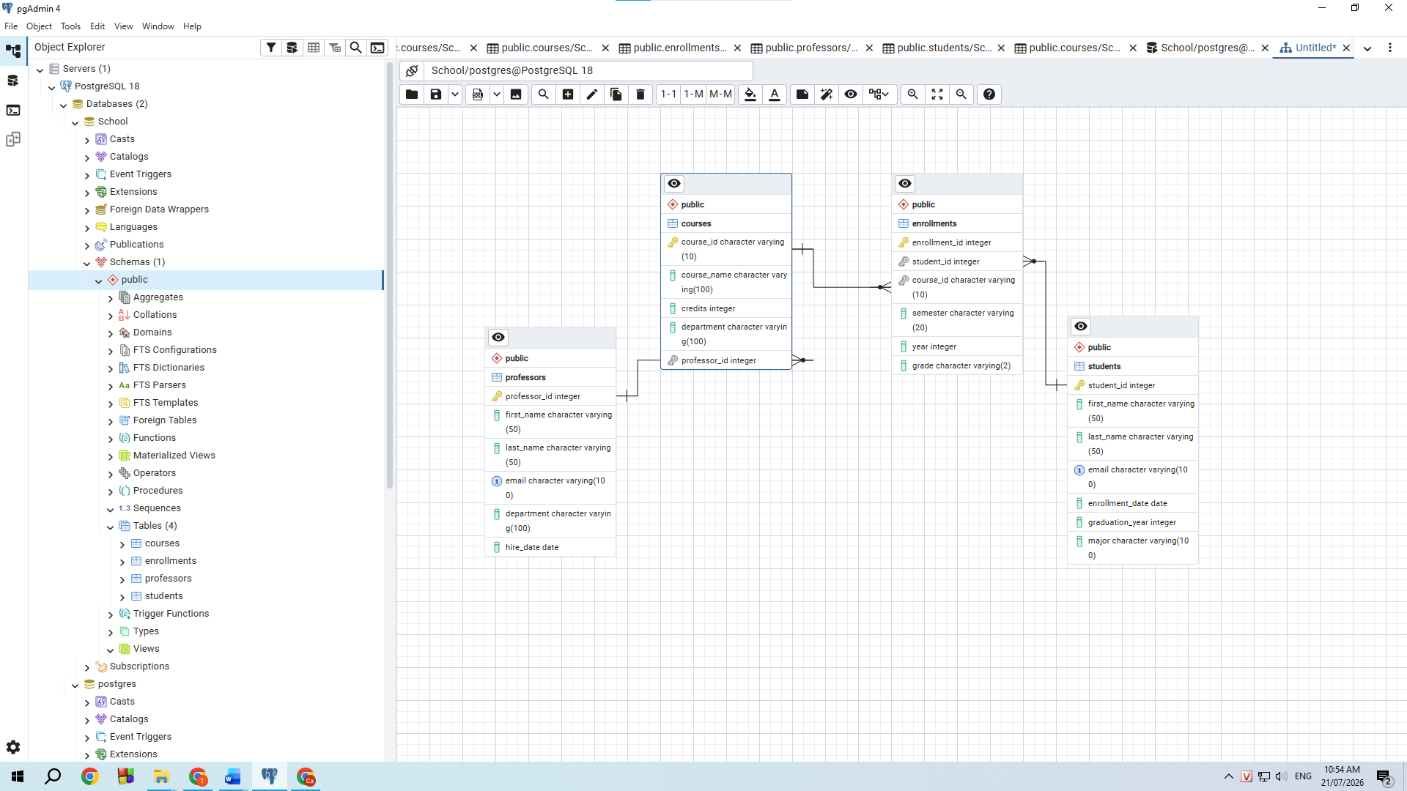
  - Summary of the database implementation
4. Summary of the completed SQL questions
5. Selected pgAdmin screenshots
QUESTION 1:
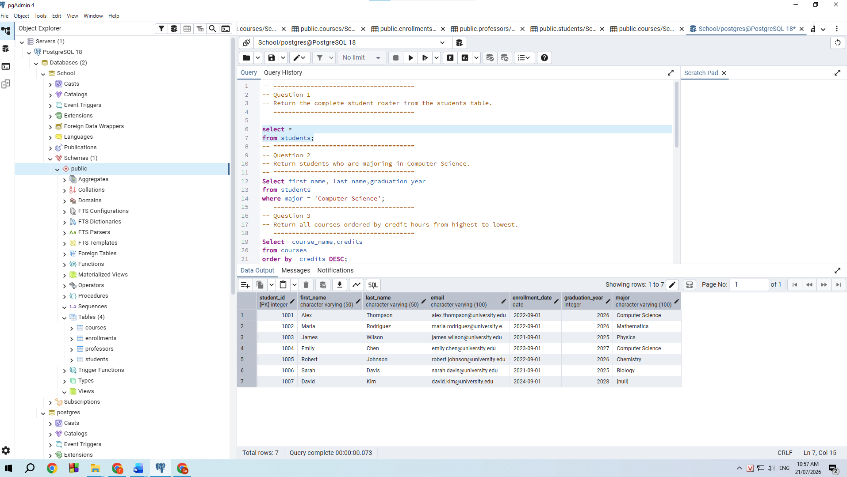
QUESTION 2:
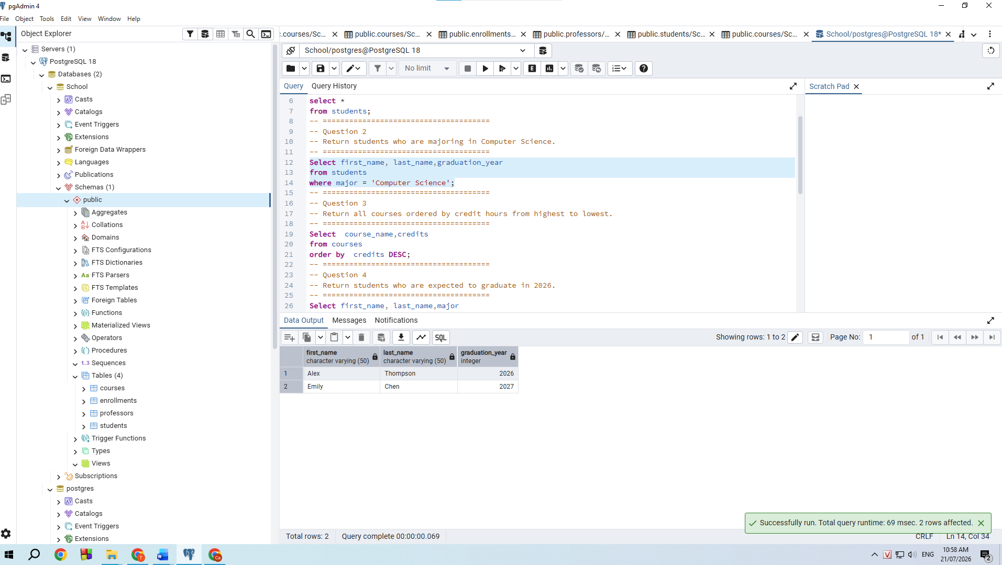
QUESTION 3:
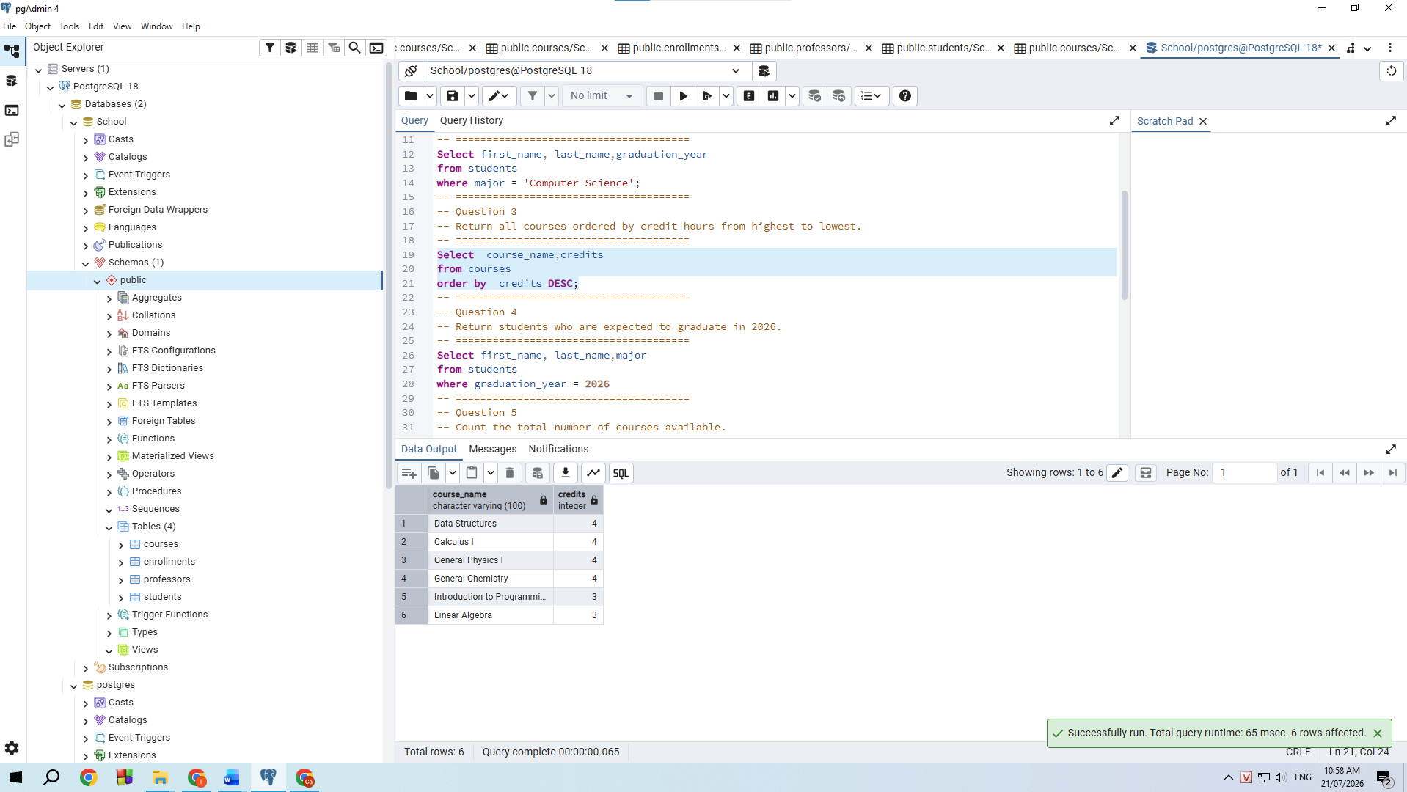
QUESTION 4:
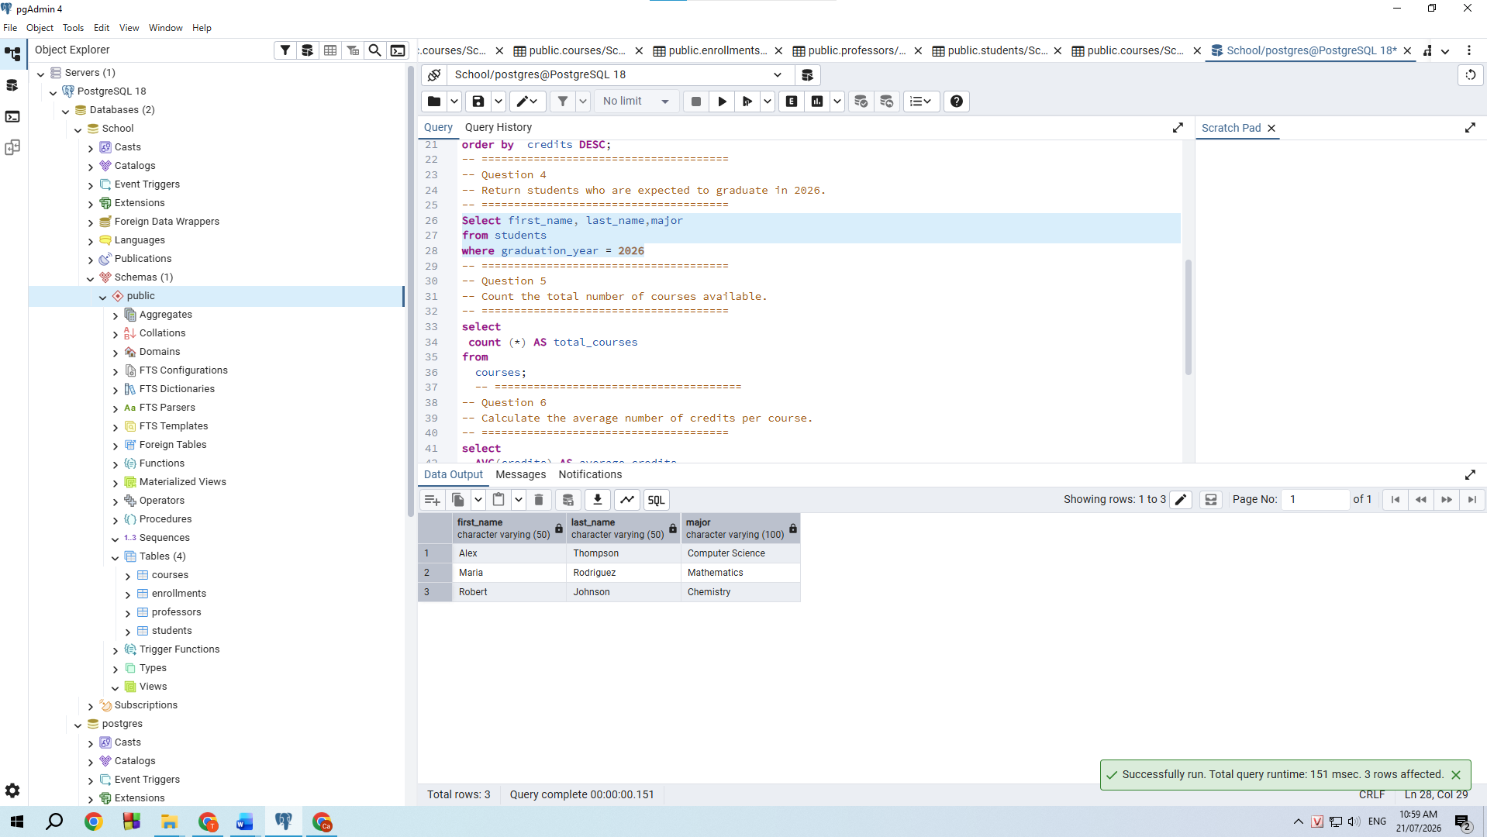
QUESTION 5:
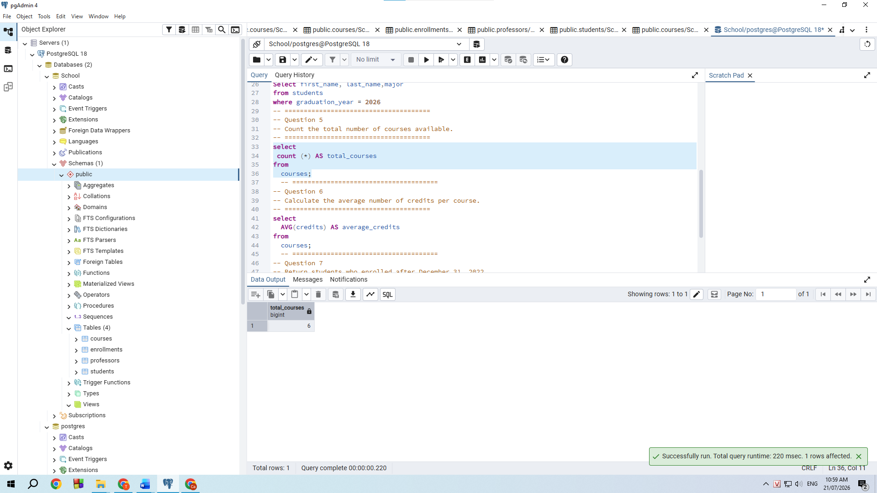
6.Challenges encountered and solutions
Challenge | Solution
Foreign key constraint errors when creating child tables. | Created the parent tables first (Students and Professors), followed by Courses and Enrollments.
Data insertion failed because of incorrect insertion order. | Inserted data into parent tables before inserting records into dependent tables.
SQL syntax errors caused by PostgreSQL syntax differences. | Corrected the SQL statements according to PostgreSQL syntax and tested each query individually.
Difficulty understanding table relationships. | Used JOIN queries and an Entity–Relationship Diagram (ERD) to verify the relationships between tables.
Ensuring data consistency across tables. | Verified all primary keys, foreign keys, and query results after data insertion.
codes/04_questions_01_30.sql

